Value STP Strategy:

We make statements like create STP over 3-6 months and that will take care of the volatility in Equity markets. However, what if Systematic Transfer over last 6 months could have been all in the Red Zone viz. Expensive valuation zone? Then, there is no difference between investing in Lump Sum or creating STP over 6 months. If you wish to encompass Red, Yellow and Green zones of the Equity markets, STP has to be over 4-5 years and not over shorter periods:

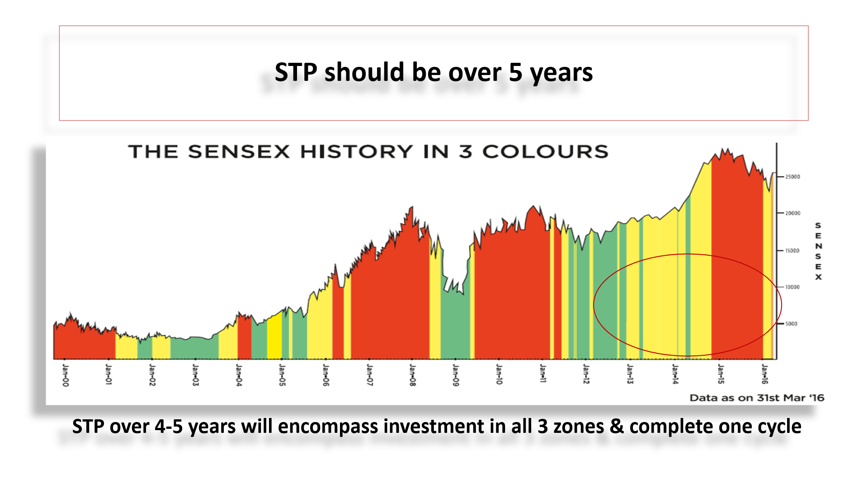

This is what we call Regular STP from Core scheme (where we park initial funds) from where Systematic Transfer (STP) will happen over your recommended Aggressive Asset Class which can be any Equity schemes. However, as I have been saying, investment is nothing but a valuation game. Why should we not do more transfers when markets are in reasonable valuation zone-say Yellow Zone and even more when markets are in Cheap valuation zone-say Green Zone?

MisterBond’s Value STP will follow 1X, 3X, 5X formula for switching from core scheme to aggressive equity schemes. Different asset classes will be selected based on Market Bands.

- 1X STP will happen in DAAF schemes - Dynamic asset allocation schemes like Balanced Advantage Fund (BAF) or Dynamic Equity schemes when markets are in Red Zone
- 3X STP will happen in Aggressive Equity schemes when markets are in Yellow zone and
- 5X STP will happen when markets are in Green Zone

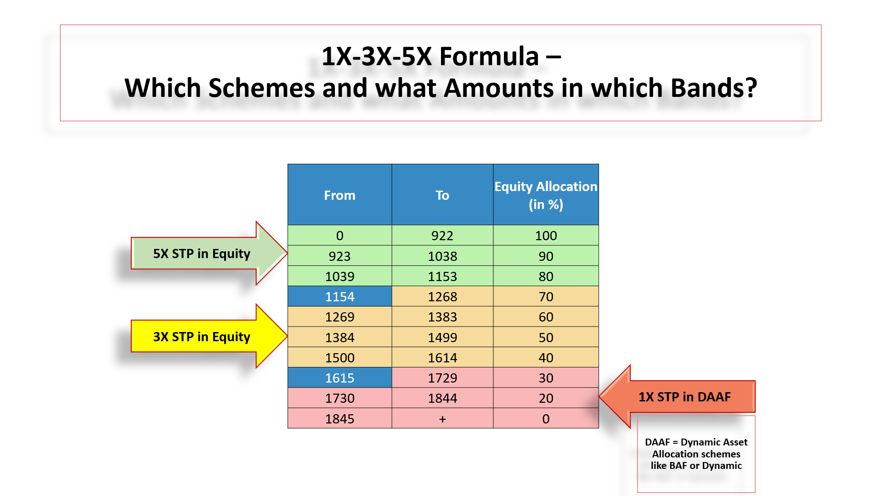

Once all the funds get transferred from Core Scheme to Aggressive Equity/DAAF schemes based on market zones (this may happen earlier than original selection of 60 installments due to better valuation opportunities); Smart Investing will take over. Value of all investments in Equity which was transferred thru 1X, 3X, 5X formula will be switched into DAAF when MisterBond’s Algo reads 1615 or higher and back to Equity when MisterBond’s Algo reads any number below 1154 and vice versa as explained in Smart Investing strategy note.

Some back tested results:

STP From 09-03-2004 to 09-03-2009 -Value in Lacs
 | Core Investment in Liquid Scheme | Equity Scheme | Dynamic/BAF Scheme | Value as on 07-01-2009 | Strategy Outperformance | Returns CAGR %
Initial Investment | 60
Only STP | 9.50 | 56.88 |  | 66.38 |  | 2.04
Value STP |  | 140 |  | 140 | 73.47 | 18.43

Above is strategy results of Value STP v/s Regular STP in the worst market conditions – when markets corrected by 60% and was at its lowest on March 09’2009.

STP From 09-03-2004 to 21-03-2019 -Value in Lacs
Smart Investing taking over Post Value STP from 09-03-2004 to 09-03-2009
 | Core Investment in Liquid Scheme | Equity Scheme | Dynamic/BAF Scheme | Value as on 07-01-2009 | Strategy Outperformance | Returns CAGR %
Initial Investment | 60
Only STP | 9.50 | 443 |  | 443 |  | 14.21
Value STP |  |  | 1286 | 1286 | 843 | 22.60

Above is result of Value STP v/s Regular STP and thereafter Smart Investing taking over.

Recommended Asset Classes for Core, STP and Smart Investing schemes for different Age groups:

Recommended Selection of Schemes for Value STP Strategy:
For Non-senior citizens: (age group up to 50-55 years)
Lump Sum Parked in Core Scheme:
Liquid/Ultra Short Term/Equity Income/Equity Savings%%
STP into Aggressive Equity Scheme:
Any Equity scheme
Smart Investing Switch into Conservative Scheme:
Any Dynamic Asset Allocation Fund (DAAF) i.e. Balanced Advantage Fund (BAF) or Dynamic Equity schemes
For Senior citizens: (age group up to 55 years & above)
Lump Sum Parked in Core Scheme:
Liquid/Ultra Short Term/Equity Income/Equity Savings
STP into Aggressive Equity Scheme:
Any Dynamic Asset Allocation Fund (DAAF) i.e. Balanced Advantage Fund (BAF) or Dynamic Equity schemes
Smart Investing Switch into Conservative Scheme:
Liquid/Ultra Short Term/Equity Income/Equity Savings**
** Ensure a scheme different from the one selected in Lump Sum Parked in Core Scheme

%% Please Check Exit Load issue in each Equity Income/Savings Fund before selecting the same

Minimum Purchase under Value STP:

- MisterBond’s Value STP will do in 1X into DAAF (if markets are in Red Zone) or 3X into Equity (if markets are in Yellow Zone), or 5X into Equity (if markets in the Green Zone)
- Since STP is not possible in two different schemes; it will be treated as new purchase every month under this strategy
- Since it is shown as purchase and not STP; minimum amount should be Rs.5,000/p.m.
- So, opt for Value STP only for those folios where your STP amount is Rs.5,000/p.m. and above. For this you will need to park Rs.3,00,000 in this example in Core Fund. However, if you park less than 3 lacs; Investor will need to top up when funds start depleting
- STP will happen automatically over 60 instalments and not over shorter periods

