Lump Sum Investments - Smart Investing:

This is an alternate strategy to make investment journey of Lump Sum strategy smoother and less volatile. This is not alternate to DAAF kind of schemes. Remember, goals of most investors are similar. Our job is to make this journey smoother and less volatile:

Most Investors invest when markets are climbing up or nearing the peak and exit when market valuations are cheap i.e. when the valuations are correcting. We need to reverse that through our strategy:

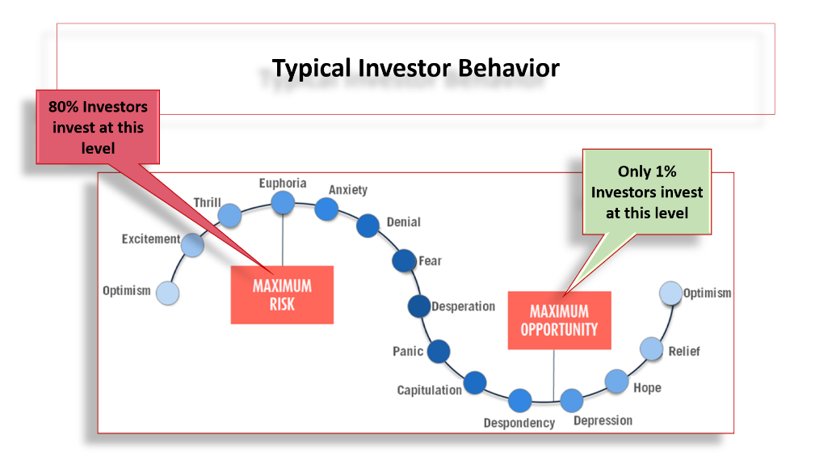

So how do we achieve that? MisterBond has created an Algo based on trailing NIFTY 50 PE and PB. Every day this Algo number is declared based on Market Valuations. Different bands for Debt and Equity allocation are created based on these numbers. However, of critical importance are two Algo numbers (Triggers); one in the Expensive Zone (Red Zone) which suggests markets are expensive and hence funds should move from Aggressive Asset Class (Equity schemes) to Conservative Asset Class (DAAF schemes) and one in the Cheap Valuation Zone (Green Zone) which suggests that funds should move back from Conservative Asset Class (DAAF schemes) to Aggressive Asset class (equity schemes). Following are the Algo Bands and two binary trigger points:

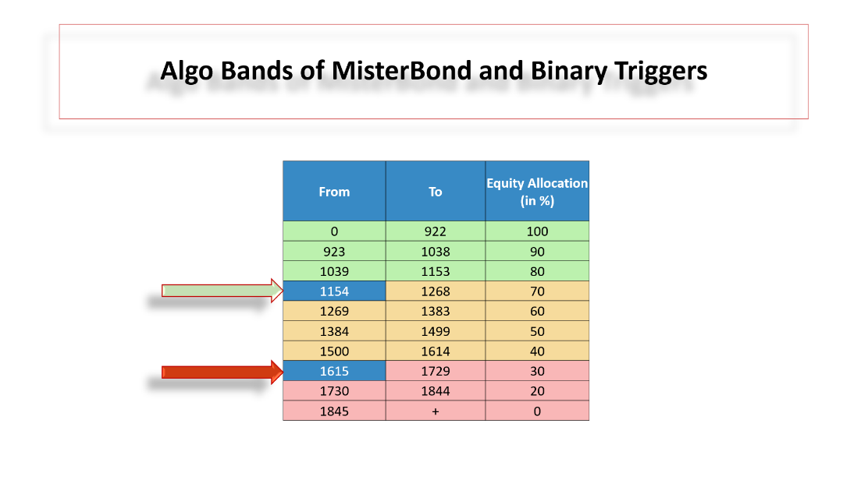

Funds will move from Aggressive to Conservative Asset classes and vice versa based on these two Algo numbers:

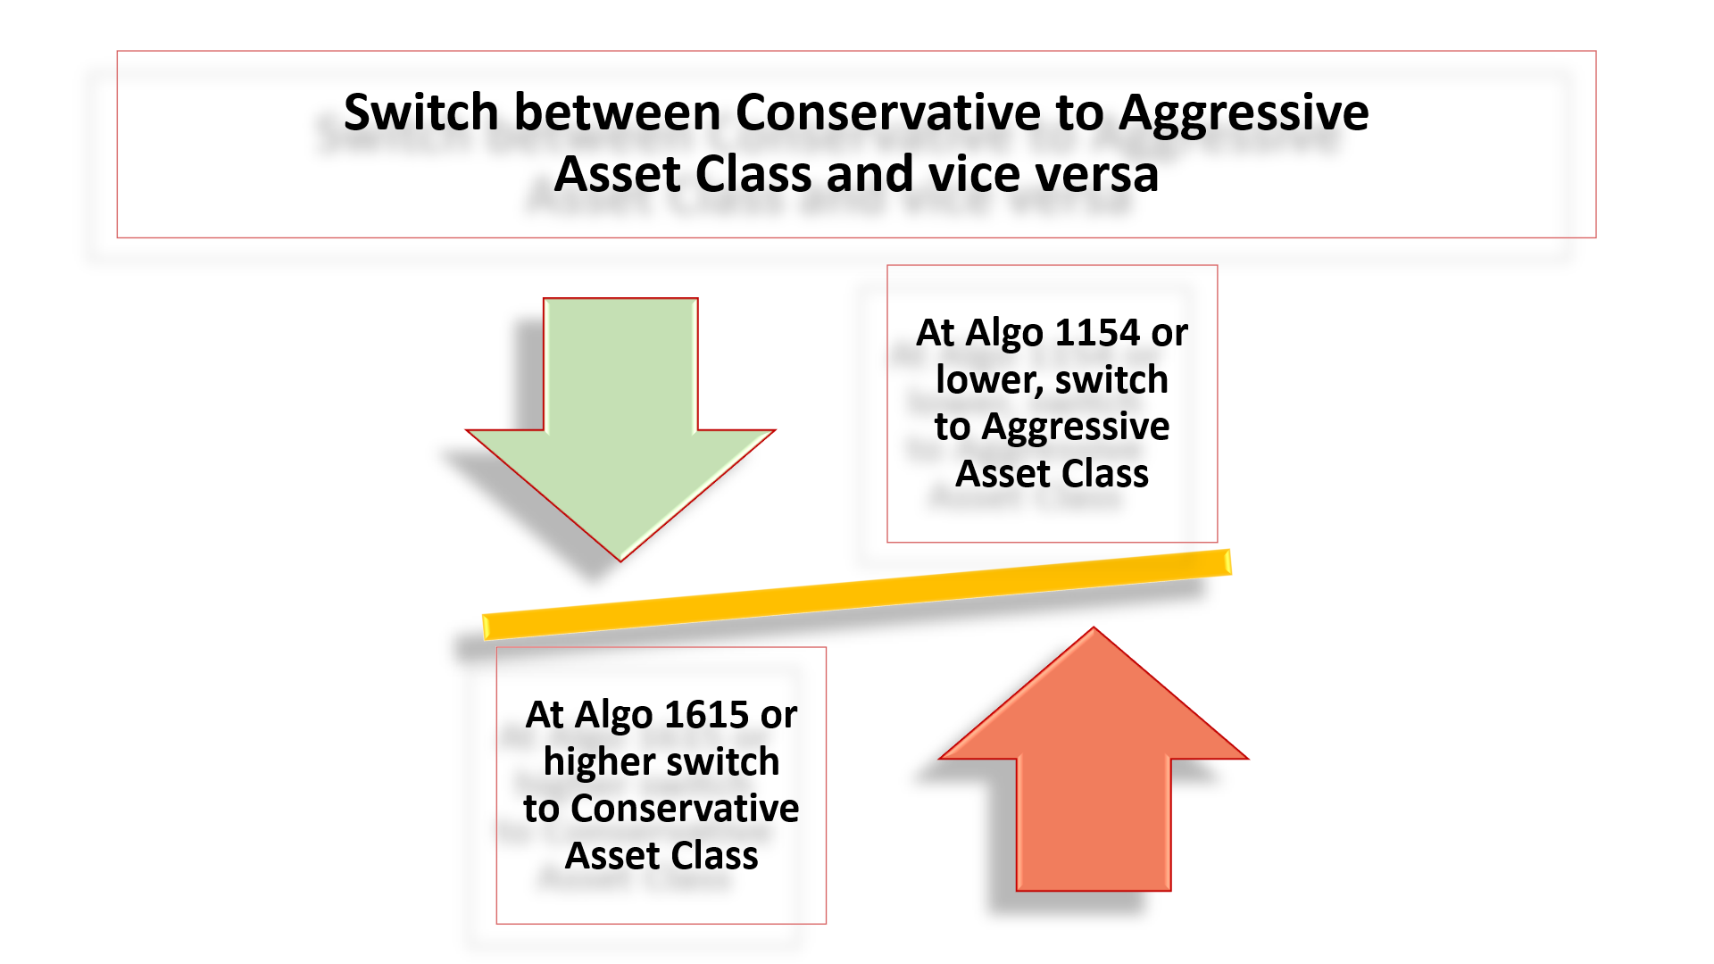

Above strategy will not only help in DOWNSIDE PROTECTION; but will help Investors to be in the right Asset Class at right Valuations.

Any Investments in lump sum strategy will be decided based on these Bands of MisterBond i.e. when the markets are in Green and Yellow Zones; any investments will be pushed into selected Equity schemes. However, if on the date of investment, the Band is in the Red Zone; automatically funds will be invested in your selected DAAF scheme of the same Fund House. Future switches will be decided (automatically) based on the above two Trigger Algo numbers.

How to use this strategy for Senior Citizens:

Funds should not be in invested as lump sum in pure Equity schemes for anyone in the age bracket of senior citizens or about to be senior citizens like (50-60 years of age). Their lump sum investments should be in DAAF (this becomes their aggressive asset allocation scheme) and switch should happen in Liquid/Ultra Short Bond Fund (their conservative scheme) and vice versa. We must protect senior citizens from extreme volatility which is part and parcel of Equity as an asset class and at the same time infuse some flavors of equity through DAAF schemes.

Recommended Asset Classes for Lump Sum investments under Smart Investing for different Age Groups and their respective switches into Conservative Asset Classes:

Recommended Selection of Schemes for Smart Investing Strategy:
For Non-senior citizens: (age group up to 50-55 years)
Lumpsum into Aggressive Scheme
Any Equity scheme
Smart Investing Switch into Conservative Scheme
Dynamic Asset Allocation Fund (DAAF) i.e. Balanced Advantage Fund (BAF) or Dynamic Equity schemes
For Senior citizens: (age group up to 55 years & above)
Lumpsum into Aggressive Scheme
Any Dynamic Asset Allocation Fund (DAAF) i.e. Balanced Advantage Fund (BAF) or Dynamic Equity schemes
Smart Investing Switch into Conservative Scheme
Overnight/Liquid/Ultra Short-Term Bond Fund

A word of caution:

While opting for this strategy for your existing Investor portfolios (who would have invested in lump sum in the past); please look up the Algo number. If the Algo is 1615 or higher; automatically all funds will be switched into DAAF schemes. This must be communicated to your Investors upfront. Once switched; there will be no going back.

Difference between Buy & Hold and Smart Investing Strategy:

Lump Sum Investment on 08-01-08
Current Value as on 31-12-18
Mantra: Buy & Hold (value of Rs.1 crore)
Lump Sum In | Amount | % CAGR
Equity Scheme | 3.73 | 12.73%
Sensex | 1.73 | 5.10%
Lump Sum Investment on 08-01-08
Current Value as on 31-12-18
Thru: Smart Investing Strategy of MisterBond
Lump Sum In |  | % CAGR
Equity Scheme - Smart Investing | 7.9 | 20.70%

Lump Sum Investment on 01-10-04
Current Value as on 31-12-18
Mantra: Buy & Hold (value of Rs.1 crore)
Lump Sum In | Amount | % CAGR
Equity Scheme | 13.56 | 20.06%
Lump Sum Investment on 01-10-04
Current Value as on 31-12-18
Thru: Smart Investing Strategy of MisterBond
Lump Sum In |  | % CAGR
Equity Scheme - Smart Investing | 26.22 | 25.75%

Minimum Investment under Lump Sum:

- Since there will be purchase in either Equity or DAAF based on MisterBond’s Algo and triggers; minimum investment amount should be Rs.5,000 and thereafter in multiples of Rs.5,000 and above

