Hello friends,

Let me explain the logic behind Smart Investment Solutions of MisterBond and a Step by Step approach to understanding each Solution.

Our Mutual Fund Industry has been giving Mantras like Buy & Hold, SIP Karo Bhool Jao and Do Not Time the Markets. According to me they are counter-productive and have only worked against the interests of the Investors. My question to all Advisors (wearing the hat of Investors) is did you or did you not panic during 2008-2009 market crash? Did you not exit? Answer is a resounding YES. If that be the case, how can we expect Investors to stay invested during such volatile times?

We, as Advisory community are REACTIVE rather than being PROACTIVE. We are creating ABHIMANYUS out of our Investors- stuck in CHAKRAVYUHA of Equity Investing; not knowing when to Exit or do Profit Booking. We need to change that by adopting strategies that will move investments of our Investors from aggressive asset classes (read Equity) at certain expensive market valuations to conservative asset classes (read Dynamic Asset Allocation schemes -DAAF). Of paramount importance should be to protect in built profits from downside correction. We are only concentrating on UPSIDE participation.

Remember, there are only three ways to invest in Equity Mutual Funds:

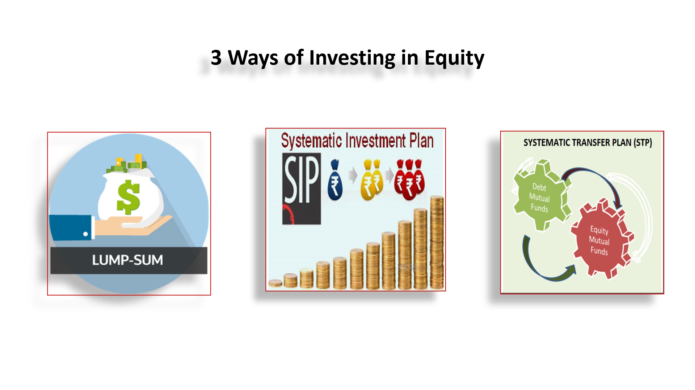

Our job as Advisors is to make this Investment Journey smoother, less volatile and based on Market Fundamentals. Hence, MisterBond has created 3 Smart Investment solutions to do exactly the same under each one of the above ways of investing in Equity Mutual Funds:

- Smart Investing Strategy: How to make Investments in Lump Sum – smoother and less volatile
- Exit Strategy from SIP and,
- Value STP (Systematic Transfer)
I have created separate notes and Videos for understanding each of the above strategies. Please go through the same which should guide you in fully understanding why an Investor should adopt this strategy, which asset classes to select for switching from Aggressive to Conservative and vice versa and many more commonly asked questions.

Please understand these in details, make your Investors understand the same and then adopt these strategies. Please do not blindly adopt them.

REMEMBER to take approvals of your Investors on the Agreement provided to you on the Platform. There are two Agreements viz. one between MSJ MisterBond Pvt Ltd and you and another between you and your Investors. These agreements are clearly specifying that these are trigger based investment solutions and hence you will not take approvals of your Investors at every trigger point. They have understood these investment solutions and they are giving one-time approval do to the same. This is extremely important step for you to safeguard yourselves from any future queries, litigations, etc.

Also, remember that these investment solutions are possible with only those Fund Houses who have DAAF as an Investment Asset class viz. either Balanced Advantage Fund (BAF) or Dynamic Equity schemes. Currently most AMCs have this Asset class. However, specific exceptions are HDFC MF and Mirae MF from among the more popular Equity Fund houses. Hence, Smart Investment Solutions should not be opted for schemes of these two Fund Houses.

With warm regards,

MisterBond

