Exit Strategy from SIP:

We have been giving Mantras like SIP Karo Bhool Jao. Is that right way of investing even through SIP strategy? Why were SIPs discontinued when markets corrected by more than 60% and SIP portfolios started generating negative returns? Or why are SIPs getting discontinued now (March 2019) when once again last 2-3-year SIP returns have delivered negative or negligible returns?

Answer is very clear; most Investors have started looking at SIP as a product and not a strategy. They think that if they invest through SIP; they can never go wrong. Again, here as well there is no clear Exit strategy.

Remember:

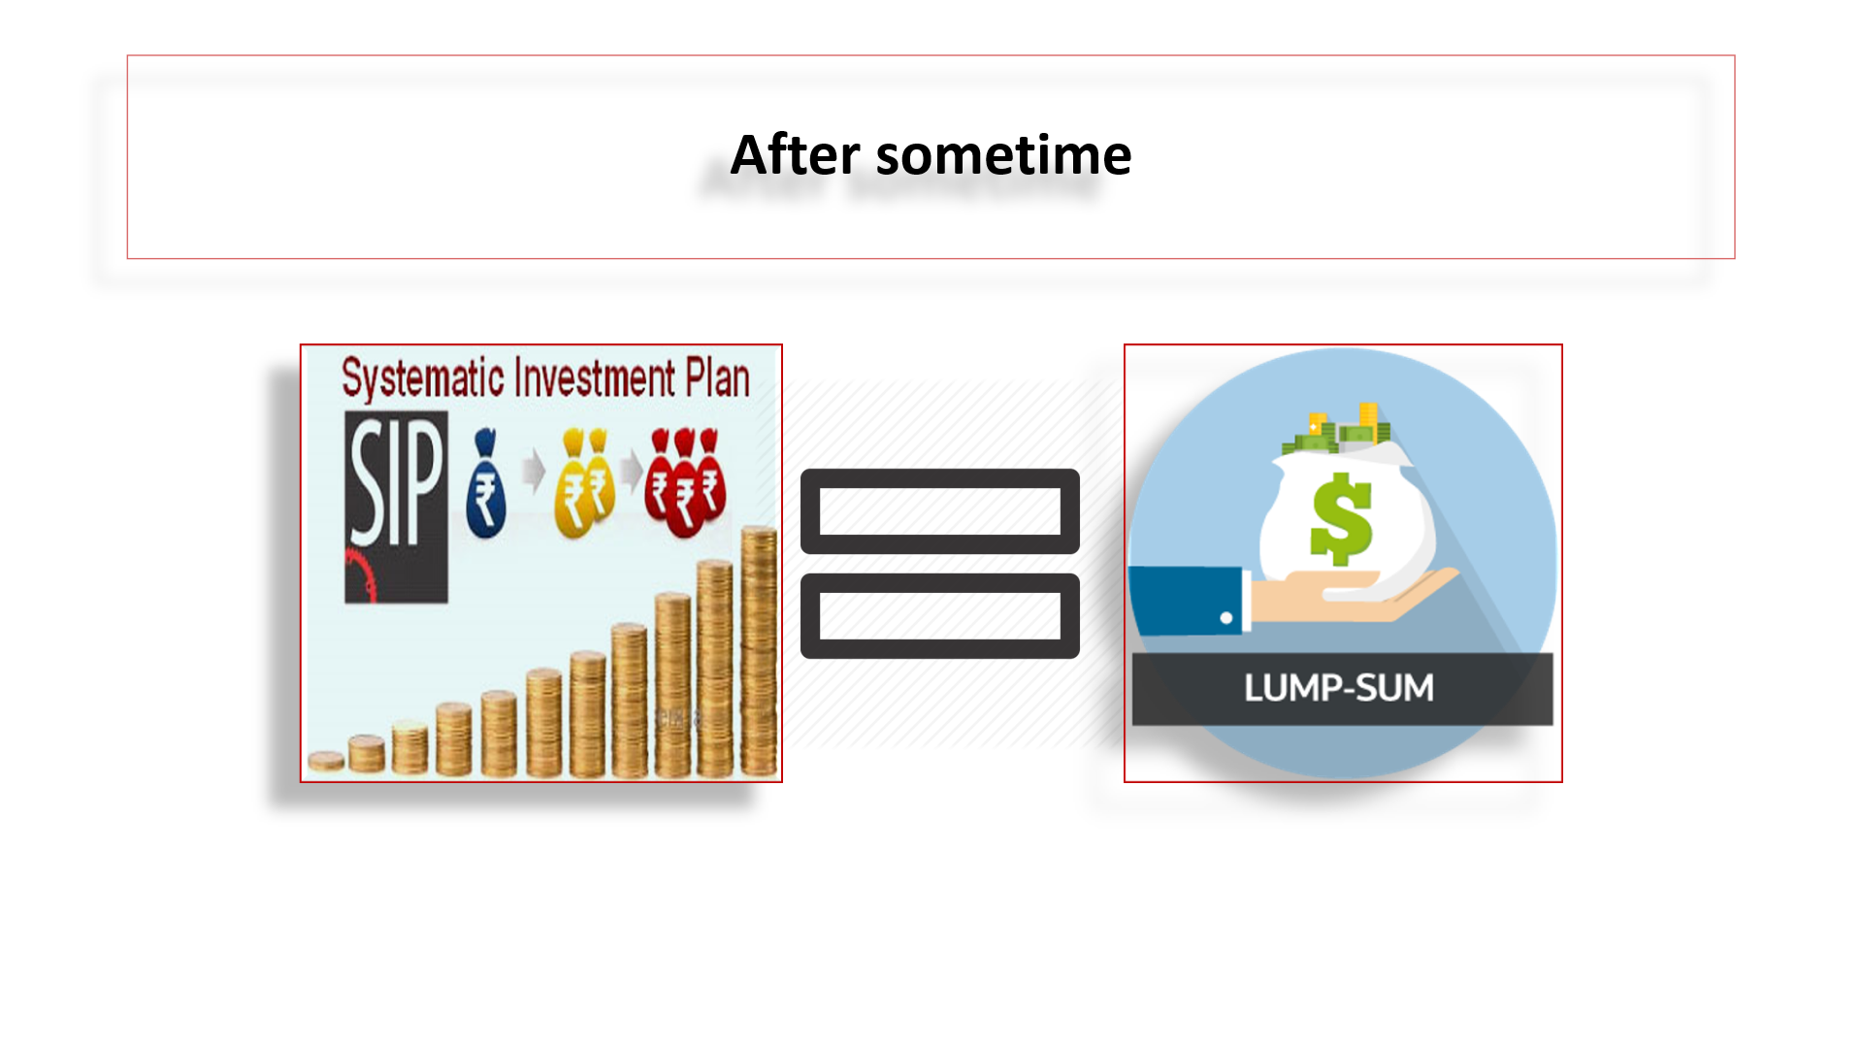
Even SIP portfolios and in-built profits need to be protected from market volatility.

Under Exit Strategy of MisterBond:
- Start your Investor’s SIP in Equity scheme
- If the markets are in Green or Yellow zones, SIP will happen in your selected Equity schemes
- At expensive market valuations (at MisterBond’s Algo at 1615 or higher); entire SIP portfolios will be switched into DAAF
- However, your future SIPs will continue
- If going forward markets are in Red Zone; SIPs will happen in DAAF and if markets are in Green or Yellow zones; SIPs will happen in the same Equity schemes
- Then Smart Investing will take over
- At cheap valuations (at Algo number less than 1154); funds switched into DAAF will move back to Pure Equity and this cycle will continue

Recommended Selection of Schemes for Exit Strategy from SIP:
For Non-senior citizens: (age group up to 50-55 years)
SIP into Aggressive Scheme
Any Equity scheme
Smart Investing Switch into Conservative Scheme
Dynamic Asset Allocation Fund (DAAF) i.e. Balanced Advantage Fund (BAF) or Dynamic Equity schemes
For Senior citizens: (age group up to 55 years & above)
SIP into Aggressive Scheme
Any Dynamic Asset Allocation Fund (DAAF) i.e. Balanced Advantage Fund (BAF) or Dynamic Equity schemes
Smart Investing Switch into Conservative Scheme
Equity Income/Savings

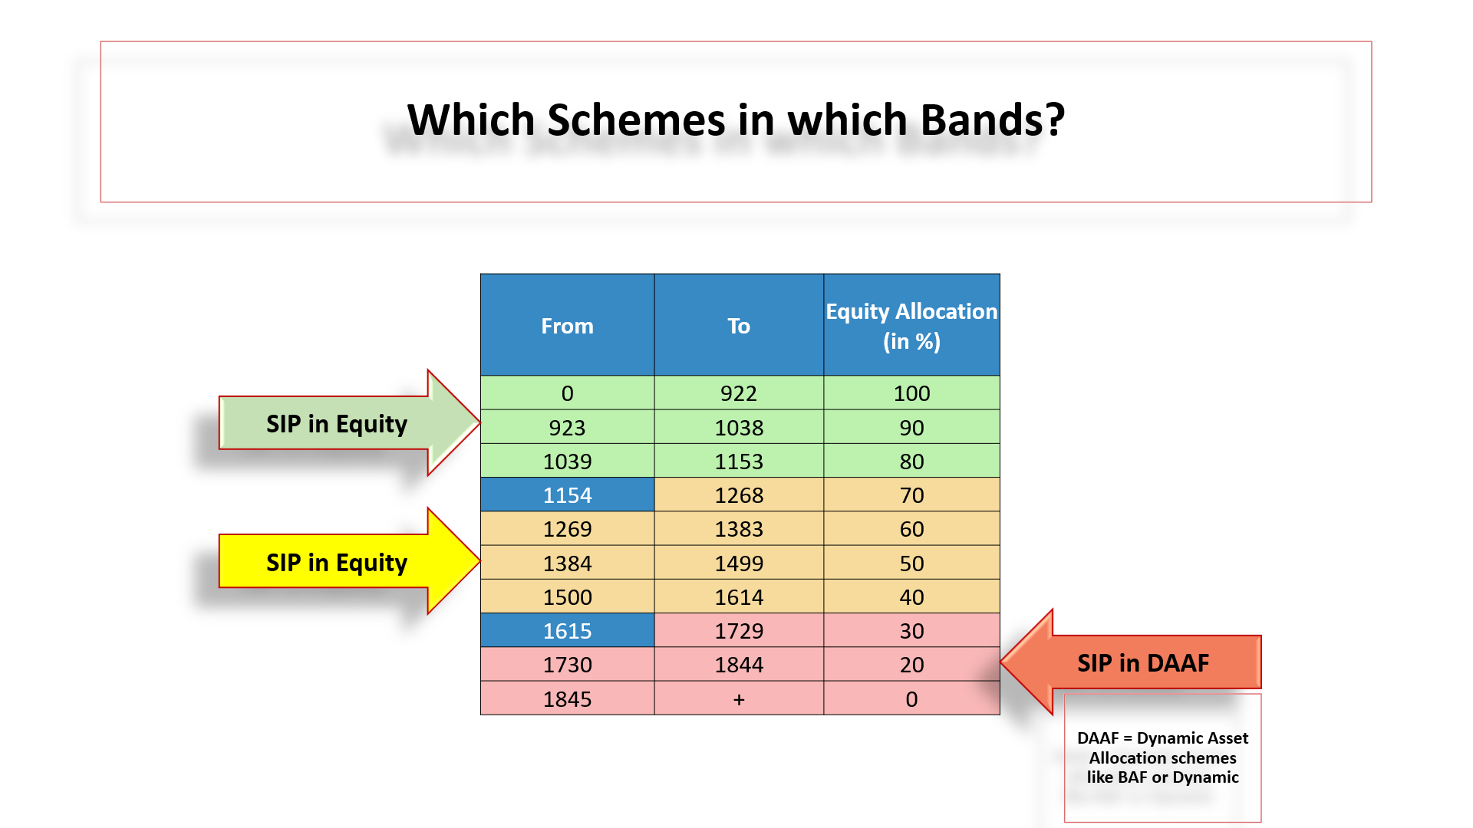

My recommendation for SIP for Senior Citizens:

We do not wish to give Senior Citizens or about to turn Senior Citizens a negative and a volatile investment experience. Ideally, their SIP should be in DAAF (their Aggressive Asset Class) and their choice for Smart Investing switch into Conservative Asset Class should be Equity Income or Equity Savings.

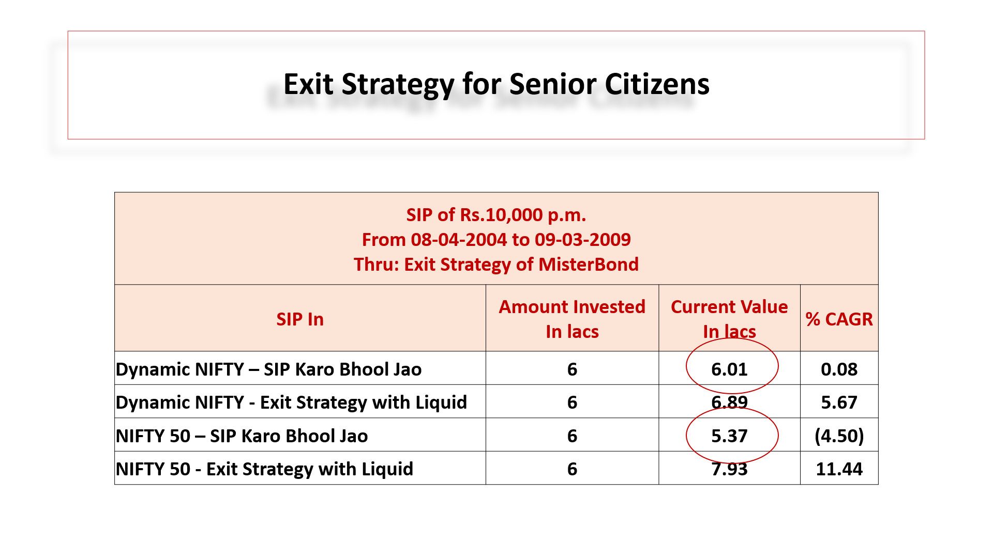
Minimum SIP Purchase:

- MisterBond’s Exit Strategy will do SIP in DAAF (if markets in Red Zone) or in Equity (if markets are in Green or Yellow zone)
- Since SIP is not possible in two different schemes; it will be treated as new purchase every month under this strategy
- Since it is shown as purchase and not SIP; minimum amount should be Rs.5,000/p.m.
- So, opt for Exit Strategy from SIP only for those folios where your SIP amount is Rs.5,000/p.m. and above

A word of caution:
While opting for this strategy for your existing Investor portfolios (who would have invested in SIP in the past); please look up the Algo number. If the Algo is 1615 or higher; automatically all accumulated SIP portfolio will be switched into DAAF schemes. This must be communicated to your Investors upfront. Once switched; there will be no going back.

